Quast. Oliver

The cold-calling guide is designed to help you make phone calls with less inhibitions and more success in cold calling. The focus is on a respectful and informative initial contact, which lays the foundation for further conversations. Use the following chapters to refine your skills and skills and increase your success rate. Good luck with your telephone calls!

The cold call

A short guide

IContents

[Introduction 2](#_Toc193381381)

[1. What helps me with cold calling? 2](#_Toc193381382)

[1.1. Inner attitude: 2](#_Toc193381383)

[1.2. The time: 2](#_Toc193381384)

[1.3. The reason for the call (usually also the content of the acquisition): 2](#_Toc193381385)

[2. telephone guide 3](#_Toc193381386)

[2.1. The AIDA principle 3](#_Toc193381387)

[2.2. Seven seconds 4](#_Toc193381388)

[2.3. The phone call 4](#_Toc193381389)

[2.3.1. The Pleasant “Yes” Path 5](#_Toc193381390)

## Introduction

Hello and welcome to the cold calling guide.

This document is intended to help you in your day-to-day dealings with new customers or prospective customers when cold calling and is not intended to be the last word in wisdom.

Rather, it is intended to reduce inhibitions during the first telephone calls to a bearable level and to make the exchange as pleasant and informative as possible for yourself and for our “listeners” (prospective customers or customers).

And remember, those who say to you:

“And if you already have the prospective customer on the line, please ask him about points A, B and C.”

have not often practiced cold calling.

Anyone who comes up with the idea of wanting to generate/create any additional benefits in addition to making an appointment hasn't really been cold-calling. These are the points that we can easily ask about during the appointment or in preparation for it, without any stress.

## What helps me with cold calling?

## Inner attitude:

I offer an interested party the opportunity to help or help themselves. This is in line with my own attitude. It is important to me that everyone is as well off as possible and that no one is disadvantaged.

That is my driving force. If you have a different kind of mind, then look for the driving force you need.

If an interested party has no need or does not want to talk to me, I have tried to help him in any case.

## The time:

I don't mean the time of year, but the time of day. I have the best results in the periods Mon.-Fri. 9:00 - 11:00 and 13:00 - 16:00. Fridays mostly until 14:00.

I could give a number of reasons why this is the case, but that would degenerate into a scientific paper.

## The reason for the call (usually also the content of the acquisition):

SEEBURGER AG would like to build up its business more sustainably. This only partially serves our customers, but this is also an important aspect of acquisition. A solvent, commercially sound company will still be there for its customers tomorrow.

In this context, the idea of the cloud has also established itself in the DACH region. Companies such as SEEBURGER AG can therefore offer their customers a range of added value/services and are no longer dependent on pure software sales and maintenance. Instead, there is a partnership, a symbiosis between client and contractor. As a result, a company like SEEBURGER AG has a constant source of income and is not dependent on pure maintenance to secure its income in the long term.

Many medium-sized but also large companies can hardly fulfill the currently necessary security requirements for their IT infrastructure, nor for the software they use. The situation is different for data centers and their services and the software they use. As a cloud must meet the very highest standards, every customer can participate in these requirements. Our data center is thoroughly tested and certified every two years.

This benefits all customers, both premium customers and €450 customers.

This is one of the key aspects of acquiring a cloud-based service and one of the sharpest swords we can and must wield.

## telephone guide

## The AIDA principle

It should only be mentioned here for the sake of order. This is the pattern of the last 40-50 years. Not much has changed here and not much will change in sales psychology.

Basically, it's always the same game. Everyone develops their own “scam” over the years in order to depict the “A”. My motto is always: “Different from everyone else”. Every guide that has accompanied me over the last 30 years always says: “Never ask if someone has time, they'll always say they don't.” Bullshit! If my counterpart doesn't have time for a phone call, then maybe now, but not tomorrow or any other day. The only important thing is that if you tell the prospective customer that you will get back to them at a certain time, it is best to do this one minute before the agreed time in German-speaking countries.

A = Attention (opening the conversation)

I = Interest (arouse interest)

D = Desire (arouse need)

A = Action (closing (appointment))

Put yourself in your own position if your provider calls you at home to change your mobile phone tariff or order the latest Internet offer.

Are you asked if you have a moment? I don't. You probably just blather on and want to reel off your “guide”. That's already boring in the first few seconds and I usually nip it in the bud. It doesn't win you anything, at least not with me. I find it extremely rude and intrusive. Now this is not B2B sales, but B2C, but the pure feeling is always the same.

## Seven seconds

The first seven seconds are the crucial seconds. Do I manage to convince my counterpart of me, of my person? It's not about being a mouse, not an elephant. Eloquent, not pushy, politely courteous with the most pleasant voice possible. Not excited but not too cool and bored either. Take your mobile phone and use the dictation function to record yourself. Don't judge yourself too harshly, no master has fallen from the sky. Play different versions of the first seven seconds over and over again. Eventually you will find the right intonation.

## The phone call

Are you excited? Good, that wakes us up and makes us more attentive. Put down paper and (no joke) a soft pencil, it always writes. Speak and type loudly and clearly on the phone? Ask yourself whether you would want to do the same if someone called you. A soft pencil on a pad makes little to no noise and always writes, which is more than you can say for some ballpoint pens. And take notes. A good help for paraphrasing during the phone call and for writing down the information in the CRM later.

Create a pleasantly quiet environment. Since we are in the B2B business, we owe it to our listeners not to offer them a call center backdrop with background murmuring. Sit up straight and smile! No joke either. It has something to do with self-programming. Someone who smiles speaks differently than someone with the corners of their mouth hanging down. Always drink something in between to keep your vocal chords soft. Don't get diarrhea. Just follow the simplest but most important basic rule of rhetoric."Wer Fragt führt!"

The sooner we manage to get our contact person to tell us about themselves, the sooner we will know how and whether we can help them. And don't forget, we want an appointment! This can be achieved, for example, by asking irritating questions and leaving them unanswered. This gives the other person the feeling that they don't know something or are missing out on something and you are the one who sees and can help them out of this misery. All he has to do is agree to an appointment.

Breathing pauses are also a way of building up tension or eliciting reactions that should not be underestimated. They also allow you to calm yourself down and think through your next steps.

## The Pleasant “Yes” Path

Where there is a “no” or “yes” in this area, it is always possible that you will get the customer to “tell”. That's what we want. This gives us the information we need to build up “deadline pressure”.

(The doorbell rings, the tension rises, we are ready and willing to make an appointment)

(Yes path)

You:

(If you don't understand the name, always ask! This shows our counterpart that it is important to us).

Hello and good afternoon, am I speaking to <<person>>?

My name is <<your surname>>,

half a second pause,

<<your first and last name>> I work in the <<your job title>> department at SEEBURGER AG.

Interested party:

(Pause briefly and listen for a “Good afternoon” or other phrase).

You:

Do you have a minute/is it just now or may I come through/call again later etc. (as I said: “different from everyone else”)

(Seven seconds are up) if the person does not hang up, we are through here and the person will continue to listen to us.

Yours:

“Fine. Are you the right person to talk to about XY?”

Interested party:

“Yes”. (If you answer “No”, we will do everything possible to find out the name of the “right” person and the extension number).Ihr:

“Prima.” (or any other phrase but always praising. Everyone likes to be praised)

“I would like to make an appointment with you for (e.g. WebCast) topic XY”.

(You may already be turned away here. That's not a bad thing, then we'll help someone else. In any case, the cat is out of the bag and everyone knows what the phone call is for and your counterpart can decide how to proceed. If he doesn't say anything then let's go to the yes staircase).

(Yes stairs)

Ask a stimulus question (can also be answered with a “no” - that's fine)

You:

“Are you implementing <<the topic>> yet?”

Interested party:

“Yes.”

Yours:

“Very good. Then you already know SEEBURGER AG?”

Interested party:

“Yes.” Here comes a “No.” Then continue with².

Yours:

“Are you already familiar with our cloud offerings on the topic of integration?”

If the customer says “no”, we have a chance to surprise them and tell them so:

Yours:

²"Then we should urgently make an appointment.”

Important! Under no circumstances should you say more than that, otherwise you will catch an objection that you will have to justify again. Don't use explanatory phrases like “...we can discuss topic XY in more detail.” Then the customer will dismiss you. Instead, say right away, almost in one breath:

Yours:

“When does it suit you better? I still have day X or Y for you? In the morning or in the afternoon? (Important! You decide the time.)”

(Give him the remote control. But please only with two buttons that both suit you. This gives the customer the feeling of having a choice and this makes him feel positive and he no longer thinks about why he didn't actually want an appointment. And you have an appointment that suits you and gives the customer the feeling that you have time for them despite your “tight” schedule).

Interested party:

(Pause briefly and listen for a “Hello” or another phrase).

Yours:

Do you have a minute/is it just now or may I come through/call again later etc. (as I said: “different from everyone else”)

(Seven seconds are up) If the person doesn't hang up, we're through here and the person will continue to listen to us.

Yours:

“Fine. Are you the right person to talk to about XY?”

Interested party:

“Yes.”

Yours:

“Great”. (or any other phrase, but always praising. Everyone likes to be praised)

“I would like to make an appointment with you for (e.g. WebCast) topic XY”.

(You may already be turned away here. That's not a bad thing, then we'll help someone else. In any case, the cat is out of the bag and everyone knows what the phone call is for and your counterpart can decide how to proceed. If he doesn't say anything, go to the Yes staircase).

(Yes staircase)

Ask a probing question (can also be answered with a “no” - that's fine)

You:

“Are you implementing <<the topic>> yet?”

Interested party:

“Yes.”

Yours:

“Very good. Then you already know SEEBURGER AG?”

Interested party:

“Yes.” Here comes a “No.” Then continue with².

Yours:

“Are you already familiar with our cloud offerings on the topic of integration?”

If the customer says “no”, we have a chance to surprise them and tell them so:

Yours:

²"Then we should urgently make an appointment.”

Important! Under no circumstances should you say more than that, otherwise you will catch an objection that you will have to justify again. Don't use explanatory phrases like “...we can discuss topic XY in more detail.” Then the customer will dismiss you. Instead, say right away, almost in one breath:

Yours:

“When does it suit you better? I still have day X or Y for you? In the morning or in the afternoon? (Important! You decide the time.)”

(Give the remote control to the customer/prospective customer. But please only with two buttons that both suit you. This gives the customer the feeling of having a choice and this makes him feel positive and he no longer thinks about why he didn't actually want an appointment. And you have an appointment that suits you and gives the customer the feeling that you have time for them despite your “tight” schedule).

***This is just the beginning the document will continue to grow when I have the time***

From Oliver Call 20/03/2025

* Usare I competitor. Partire dall’analisi, quindi i pain point e usarli come gancio (per l’EDI ad esempio
* API: lifecycle dell’API. Hai un API gateway? Lo sai cosa succede se non ce l’hai? Hai una porta aperta. Prenderli per paura
* Chiamare qualcuno di cui non hai info solo se lo vuoi invitare a qualche evento

USARE SEMPRE UN GANCIO

**Aalan Ruchtein -** <https://www.linkedin.com/posts/alanruchtein_no-wonder-your-cold-emails-arent-landing-activity-7314987865447325696-NWby?utm_source=share&utm_medium=member_desktop&rcm=ACoAABR6GCcBhQFYMJOP-YvG8dFomZ3wH0YkopY>

No wonder your cold emails aren’t landing meetings. Here’s how to fix it now (email example included):  
  
→ One unique clear ask.  
→ Start with a strong WHY.  
→ Stay under 70 words long.  
→ Pitch solutions, not products.  
→ End decisively, skip “Thanks!”  
→ Relevance cuts through noise.  
→ Use social proof to build trust.  
→ Write clear, skimmable content.  
→ Interrupt copywriting the pattern.  
→ Speak to their goals, not features.  
→ Interest calls to action drive replies.  
→ Ditch buzzwords; use their language.  
→ Subject lines make or break open rates.

𝗨𝘀𝗲 𝘁𝗵𝗶𝘀 𝗳𝗿𝗮𝗺𝗲𝘄𝗼𝗿𝗸:  
  
1. Trigger  
2. Process + Pain Agitation  
3. Social Proof  
4. Soft, interest-based CTA  
𝗘𝘅𝗮𝗺𝗽𝗹𝗲:  
  
"subject: onboarding  
  
Hi [name] – saw you're hiring 3 SDRs. Thought you might be looking into ways to optimize onboarding.  
  
Typically, hiring means longer, and more complex ramp-up processes.  
  
Meaning, every extra month an SDR takes to ramp is lost revenue, and missed pipeline.  
  
ACME reduced from 4 to 2 months of the ramp-up process in 90 days working together.  
If we could help you get the same results, would that be worth a chat?"  
  
\_\_\_\_\_\_\_\_\_\_\_\_\_

<https://www.linkedin.com/posts/quotaleague_i-get-a-55-response-rate-on-linkedin-dms-activity-7314980309991632897-deOR?utm_source=share&utm_medium=member_desktop&rcm=ACoAABR6GCcBhQFYMJOP-YvG8dFomZ3wH0YkopY>

I get a 55% response rate on LinkedIn DMs.   
  
5 steps how you can get the same:  
  
1. 𝗗𝗮𝗶𝗹𝘆 𝗰𝗼𝗻𝘁𝗲𝗻𝘁 𝗰𝗿𝗲𝗮𝘁𝗲𝘀 𝗮𝘄𝗮𝗿𝗲𝗻𝗲𝘀𝘀   
↳ My content is seen by 50,000+ people daily.  
↳ It’s written for my ideal prospect & buyer persona.  
↳ I don’t have to find clients - THEY find ME.  
  
2. 𝗢𝗽𝘁𝗶𝗺𝗶𝘀𝗲𝗱 𝗽𝗿𝗼𝗳𝗶𝗹𝗲 𝘀𝗽𝗮𝗿𝗸𝘀 𝗶𝗻𝘁𝗲𝗿𝗲𝘀𝘁   
↳ My profile works like a landing page.   
↳ It's crystal clear who I help and how.   
↳ I monitor all 200-250 profile views DAILY.  
  
3. (𝗕𝗹𝗮𝗻𝗸) 𝗰𝗼𝗻𝗻𝗲𝗰𝘁𝗶𝗼𝗻 𝗿𝗲𝗾𝘂𝗲𝘀𝘁 𝗯𝘂𝗶𝗹𝗱𝘀 𝗰𝘂𝗿𝗶𝗼𝘀𝗶𝘁𝘆   
↳ 60% acceptance rate without personalisation.  
↳ Skip the message in the request. Leave some intrigue.  
↳ If they perceive you as a value add, they will connect.  
  
4. 𝗤𝘂𝗶𝗰𝗸, 𝘁𝗮𝗿𝗴𝗲𝘁𝗲𝗱 𝗿𝗲𝘀𝗲𝗮𝗿𝗰𝗵   
↳ 1 minute on their profile, 1 minute on their company.   
↳ Build a problem statement with these 2 data points.  
↳ No need to over-research if you stay persona-specific.  
  
5. 𝗪𝗮𝗹𝗸𝗶𝗻𝗴 𝘃𝗶𝗱𝗲𝗼 𝗺𝗲𝘀𝘀𝗮𝗴𝗲𝘀 𝘀𝗶𝗴𝗻𝗮𝗹 𝗵𝗶𝗴𝗵 𝘀𝘁𝗮𝘁𝘂𝘀   
↳ <60sec videos via LinkedIn mobile app taken outside  
↳ Shows I'm in motion (signals high status)  
↳ Performs WAY better than sitting in my home office.  
  
That's it - my entire LinkedIn DM strategy in one post.  
  
I cannot promise that you will get a 55% reply rate...  
  
But if you implement these 5 steps?  
I promise you will outperform 99% of sellers out there.  
  
♻️ Repost to cure someone from pitch slapping  
🔔 Follow [Christian Krause](https://www.linkedin.com/in/quotaleague/) for daily LinkedIn sales tips

Saverio Grossi –

<https://www.linkedin.com/posts/saveriogrossi_sto-per-dirti-una-cosa-che-ti-far%C3%A0-male-activity-7315702524852809728-0Bjm?utm_source=share&utm_medium=member_desktop&rcm=ACoAABR6GCcBhQFYMJOP-YvG8dFomZ3wH0YkopY>

Sto per dirti una cosa che ti farà male.  
  
Fare prospecting è semplice.  
  
Ecco cosa puoi fare per cominciare:  
  
✅ Step 1: Seleziona 5 Aziende   
✅ Step 2: Identifica 3 contatti per ogni Azienda   
✅ Step 3: Trova un motivo rilevante per contattarli.  
✅ Step 4: Collega quel motivo a un problema reale reale che potrebbero avere. Parti dai problemi che potrebbero avere maggior impatto  
✅ Step 5: Usa più canali per aumentare le possibilità di risposta  
  
Vai fai avanti per 5 settimane.  
  
Pro tip Step 3  
- Guarda il tuo CRM potresti trovare informazioni preziose   
- Costruisci uno schema PIR (problem, impact, root cause  
- Guarda se stanno assumendo   
- Sfrutta AI ) chstgpt  
- Collegamenti in comune  
  
Pro tip Step 4:  
  
Costruisci gli script partendo dai motivi per cui i tuoi clienti ti hanno scelto.  
Usa le loro parole, non le tue.  
  
Il tuo nuovo mantra?  
  
Non smettere mai di generare pipeline.

<https://www.linkedin.com/posts/aaron-reeves-sales_71-meetings-i-booked-in-2023-started-with-activity-7315673546083487744-oaDn?utm_source=share&utm_medium=member_desktop&rcm=ACoAABR6GCcBhQFYMJOP-YvG8dFomZ3wH0YkopY>

71+ meetings I booked in 2023 started with a cold email. Here’s how:  
  
All of them followed my “TIPS” framework:  
  
T - Trigger  
I - Implication  
P - Pain  
S - Social proof, solution, soft cta  
  
Step 1: Start with a Trigger  
  
❌ Hey, [prospect] hope this email finds you well…  
✅ Hey [name], noticed that your sales team grew by 12 AEs in the last Q  
  
No fluff, get straight into the reason why you’re reaching out, be relevant.  
  
  
Step 2: Implicaiton  
  
❌ Our product is a streamlined optimized all in one solution.  
✅ When teams grow, typically that means there’s a focus on how to ramp all the new hires.  
  
Don’t jump into your features, instead tie the trigger into a potential issue they face.  
  
Make sure it’s a common issue, talk to current customers or your AE to understand what issues your buyers are going through.  
  
This is essential for the setting up the next step.  
  
  
Step 3: Pain  
  
❌ We offer a free onboarding, and an AI platform that shows all metrics  
✅ Most VPs say they lack the time to coach the reps 1-1. So reps take 4+ months to ramp and the FY targets become nearly imposisble to hit.  
  
This step is ESSENTIAL. Talk about a common pain and the cost of ianction.  
  
What is the issue and WHY should this person care to solve it, why can’t they just leave it.  
  
Nobody cares about your features, features only have value when they solve issues.  
  
So always dig into the pain before bringing up  
  
This was just a breakdown of the first 3 stages  
\_\_\_\_\_\_\_\_\_

<https://www.linkedin.com/posts/aaron-reeves-sales_how-to-write-a-cold-email-in-5-steps-activity-7316037679853240320-Dsdt?utm_source=share&utm_medium=member_desktop&rcm=ACoAABR6GCcBhQFYMJOP-YvG8dFomZ3wH0YkopY>

How to write a cold email (in 5 steps):  
  
This got me 9% reply rates every month  
  
1. Trigger  
  
Get straight into the reason you are sending them an email, make sure it is relevant to the issues you solve for and personal to the company the email is to, example:  
  
“Was reading through your FY24 annual report John and saw you are expanding to the US from the UK”  
  
2. Implication  
  
Based on that key event, what could be a key focus for them, plant the seed of the issue or “Poke the bear” as [Josh Braun](https://www.linkedin.com/in/josh-braun/) says, example:  
  
“With the expansion, curious how you’re planning to manage currency conversion from GBP to USD?”  
  
3. Pain:  
  
Now is when we get into the main issue and more importantly what happens if they stay the same and don’t fix it, example”  
  
“Most companies use high street banks with 3% FX fees, meaning if you hit the revenue forecast from your report for FY25 that could be as much as $300,000 in fees.   
  
4. Social Proof + Solution  
  
People don’t care about what you do, they care about what you’ve done for others. SO show how you helped people like them avoid the issue.  
  
“Deel paid 0.4% on average with our online bank & saved $50,000 in extra fees.”  
  
BONUS: The bigger the gap from the current state (their pain and what it leads to) to the desired state (where you’ve helped similar companies get to) the better! So use metrics or stories to help it resonate  
  
5. Soft CTA  
  
Don’t dive straight into trying to book the meeting, instead try & start the conversation, tie it back to your value prop too to help it stand out.  
  
“If we could save you costs on transactions, would that be worth a chat?”  
  
What would you change about this email?  
  
P.S I’m working with a small group of SDRs who want to set themselves up for promotion by crushing their quota in my Q2 Fastrack Program.   
  
If you want the details DM me “OS” limited slots available

Mostra traduzione

Attiva per visualizzare un’immagine più grande,

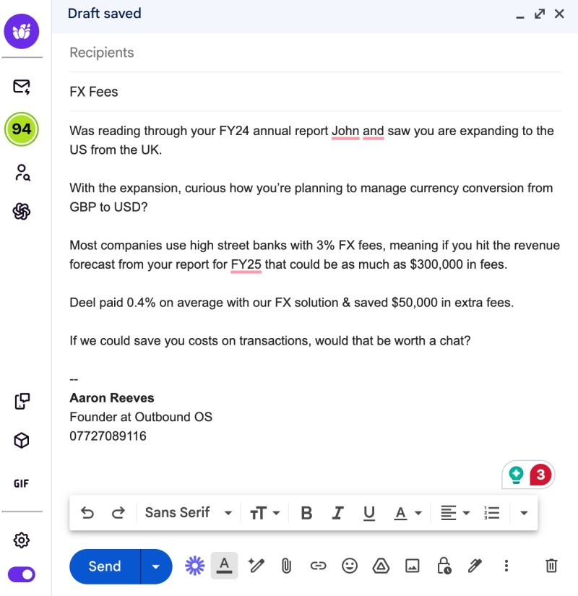

<https://www.linkedin.com/posts/josh-braun_heres-a-good-cold-email-and-the-underlying-activity-7316104102348812288-YD2y?utm_source=share&utm_medium=member_desktop&rcm=ACoAABR6GCcBhQFYMJOP-YvG8dFomZ3wH0YkopY>

Josh,  
  
Most homeowners in Boca Rio are paying around $140 every two weeks for lawn care. Roughly $3,600 a year.  
  
I run a network of independent lawn pros who batch jobs by neighborhood. That cuts travel time and overhead, so we can offer the same service for less.  
  
The Cantors are paying $100 every two weeks, or about $2,600 a year.  
  
You probably have a long-standing relationship with your current provider. I know trust beats price, especially if you’ve never had issues.  
  
Is it offensive to ask, would ever consider another option?   
  
Pete  
  
\_\_\_  
  
Here’s what’s happening under the hood:  
  
1. It opens with relevance. It’s personal but not personlalized. The same email can be sent to all homeowners in Boca Rio.   
  
“Most homeowners in Boca Rio are paying around $140 every two weeks…”  
  
That’s immediate relevance. No awkward intros. No fake flattery.  
  
Just a specific, familiar context that makes me think, “Yep, that’s me.”  
  
2. It introduces contrast—without judgment.  
  
“The Cantors… are paying $100 every two weeks.”  
  
This introduces a gap without calling the reader wrong.   
  
It doesn’t say you’re overpaying.   
It just gives you something to consider.  
  
3. It acknowledges the elephant in the room.  
  
“You probably have a long-standing relationship…”  
  
That line shows emotional intelligence. It validates the real reason people don’t switch: trust.  
  
Not price.   
Not features.  
  
4. It ends with permission, not pressure.  
  
“Is it offensive to ask, would you ever consider another option?”  
  
This is the opposite of pushy.   
It’s humble.  
It makes space instead of taking it.  
  
And it lets the prospect keep their autonomy which lowers resistance.  
  
Takeaway?  
  
Great cold emails don’t convince.  
They surface possibilities.

<https://www.linkedin.com/posts/josh-braun_the-psychology-blue-relevance-starts-activity-7315829941831368707-8heq?utm_source=share&utm_medium=member_desktop&rcm=ACoAABR6GCcBhQFYMJOP-YvG8dFomZ3wH0YkopY>

The Psychology:   
  
Blue = Relevance.  
Starts with a specific observation, fleet size + telematics. Answers “Why me instead of someone else?” It’s personal but not personalized. You can send the same email to prospects with a similar fleet size.   
  
Green = Illuminates the the cost of inaction  
The question opens a loop: “How are you ensuring you’re not overypaying?” People feel the pain of losing something more strongly than they feel the pleasure of gaining something of equal value.  
  
Yellow = Meaningfully different.  
Points out a potnetial blind spot tax data not being granular enough. Crisp, relatable. What do you know that your prospect might not know that can hurt them?   
  
Orange = Bandwagon effect.   
People are more likely to take actions because they see others like them taking action. It’s the classic “everyone else is doing it, so I should too” mindset.  
  
Pink = Labeling negatives defuses negatives.   
Addresses the biggest objection “we already have a system.”  
  
Gray = Chill CTA.  
“No rush” keeps it low-pressure. Detached.   
  
You can steal the format, but it’s the underlying psychology that will help you apply it to your prospects.

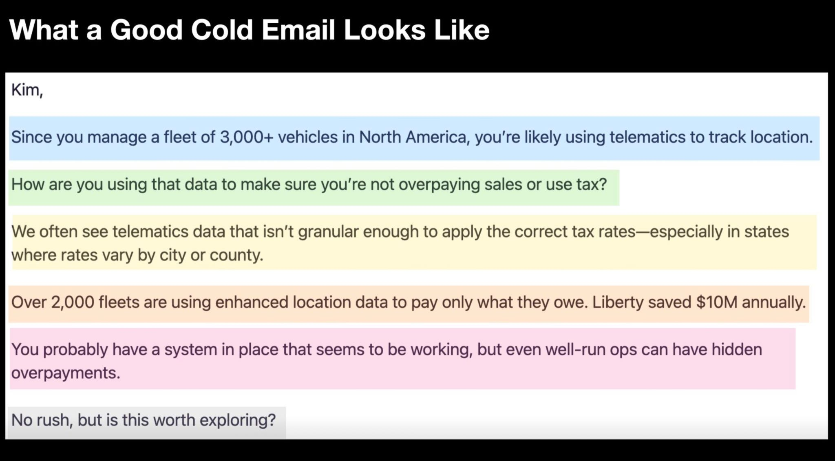

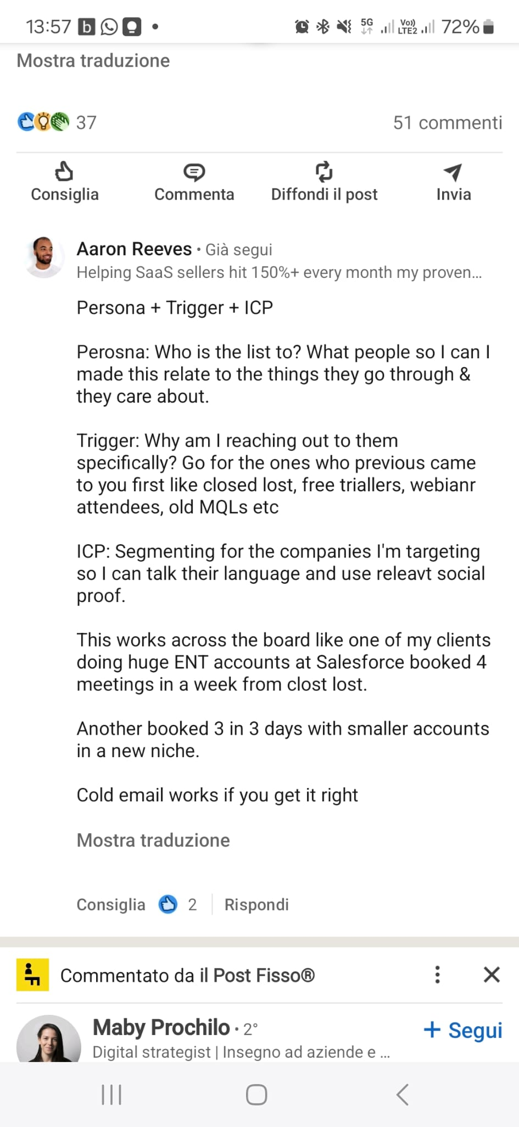

[Christian Krause](https://www.linkedin.com/in/ACoAABVHzusBxs_lZXvA8Khdlcgs9P5J_kEPYVg?miniProfileUrn=urn%3Ali%3Afs_miniProfile%3AACoAABVHzusBxs_lZXvA8Khdlcgs9P5J_kEPYVg) - https://www.linkedin.com/feed/update/urn:li:activity:7316429861349150721?updateEntityUrn=urn%3Ali%3Afs\_updateV2%3A%28urn%3Ali%3Aactivity%3A7316429861349150721%2CFEED\_DETAIL%2CEMPTY%2CDEFAULT%2Cfalse%29

If I was a full cycle AE, here's how I would prospect:  
  
(use this as a checklist)  
  
𝗜𝗻 𝗦𝗮𝗹𝗲𝘀 𝗡𝗮𝘃𝗶𝗴𝗮𝘁𝗼𝗿:  
1. Upload my territory & create tiered account lists  
2. Create 2-3 buyer personas from closed-won report  
3. Create saved lead searches to never run out of leads  
4. Organise lead lists by funnel stage: cold, 1st touch, etc  
  
𝗢𝗻 𝗟𝗶𝗻𝗸𝗲𝗱𝗜𝗻.𝗰𝗼𝗺  
5. Send 10 personalised video DMs/day (mobile app)  
6. Scan my feed for posts from target prospects  
7. Like & engage with thoughtful comments  
8. Bump video DMs daily with value  
  
𝗪𝗶𝘁𝗵 𝗖𝗵𝗮𝘁𝗚𝗣𝗧  
8. Generate new content ideas  
9. Scan 10k company reports for outreach triggers  
10. Create super hero images to bump DMs with humor   
(ask Jan Benedikt Mundorf for his genious prompt :-))

[Christian Krause](https://www.linkedin.com/in/ACoAABVHzusBxs_lZXvA8Khdlcgs9P5J_kEPYVg?miniProfileUrn=urn%3Ali%3Afs_miniProfile%3AACoAABVHzusBxs_lZXvA8Khdlcgs9P5J_kEPYVg) <https://www.linkedin.com/feed/update/urn:li:activity:7312805939970015234?updateEntityUrn=urn%3Ali%3Afs_updateV2%3A%28urn%3Ali%3Aactivity%3A7312805939970015234%2CFEED_DETAIL%2CEMPTY%2CDEFAULT%2Cfalse%29>

Today I learned a brilliant AI hack for cold calling.  
  
A BDR I mentor shared this with me👇   
  
He uses AI to generate a custom call script   
based on customer stories.   
  
For every cold call block he follows these steps:  
  
1. Builds a list of target prospects  
2. Uses ChatGPT to research their profile & company  
3. Prompts ChatGPT to write custom cold call scrips  
4. AI sprinkles in social proof & objection rebuttals  
  
Before every call he simply reads through the output,  
internalises the key talking points,  
and makes the call.  
  
He used to REALLY struggle with cold calling.  
  
But now his conversion rates are through the roof.  
  
A great example for how to use AI in sales:  
  
❌ Not for automated pitch slapping  
✅ But to save time on research & personalisation  
  
The result: a dramatically improved buyer experience.  
  
Who said the mentor couldn't learn from his mentee?  
  
♻️ Repost to share this tip with your sales team  
🔔 Follow Christian Krause for daily LinkedIn sales tips  
  
📌 PS: If you found this AI cold calling technique valuable, you'll love my weekly newsletter. Every Tuesday, I share actionable tips like this one on generating more pipeline and revenue using LinkedIn. Over 12K sales pros already read it every week, and it takes less than 5 minutes: [www.quotaleague.com](http://www.quotaleague.com)

**Cosa serve**

* [ICP: ideal customer profile](https://www.kaiti.it/ideal-customer-profile-cose-e-a-cosa-serve/) e
  + Cosa sono: **individuazione del profilo ideale della persona da coinvolgere nelle aziende selezionate (dette anche “account”)**, in modo da avere chiaro su chi dovrai concentrare tutte le tue risorse per realizzare new business o fare upselling e cross selling.
  + Perche: definire che pain point hanno e come li risolviamo noi
* Buyer persona:
  + a semi-fictional representation of your ideal customer, built from research and data about your target audience
  + Perchè: definire che pain point hanno e come li risolviamo noi
* Script/template
  + Cosa sono: schemi di email, phone, messaggi già preimpostati sulla base di quanto fatto prima. Più o meno personalizzati a seconda del tier magari. Ideale comporli 80-20 di cui 20 da ricercare trigger tra azienda, contesto, persona
  + Sulla base dei pain point goal
  + Perchè. Essere più veloci, contestuali e generare più lead
  + Come: ci sono diverse metodologia.
    - Show me you know me
    - Neat
    - T - Trigger  
      I - Implication  
      P - Pain  
      S - Social proof, solution, soft cta
    - Altro,,
* Script follow-up: vedi quanto fatto prima. Es. Definire 3 pain point e poi ricontattarli di volta in volta con un pain point
  + Cosa sono
  + Perchè: oggi ci vogliono almeno 16 touch verso un prospect prima che diventi una lead
  + Come
* Social selling
  + Cosa è: a modern sales approach that utilizes social media to connect with and build relationships with potential customers, aiming to foster trust and ultimately drive sales
  + Perchè: le persone comprano dalle persone. Creiamo una presenza e attiriamo piuttosto che doverli ingaggiare cosi da zero.
  + Come: definire die piani editoriali con un senso, non parliamo di noi ma magari degli stessi pain che risolviamo. Possiamo condividerli
* Contenuti gated🡪 posso creare una sorta di pagina personale dove pubblicare die contenuti rielaborati di whitepaper(brochure/case studies di seeburger?
  + Cosa sono
  + Perchè: raccogliere più contatti da lavorare
  + Come
* Competitor analysis
* Tempi di risposta?
  + Fammi parlare con Minimold
* Edicom?
  + Cambiano sempre i consulenti
* \_\_\_\_\_\_\_\_\_

Personal development: action, how when

Career plan, how when

compensation plan how when

need tools to make the job as for today:

* When will come the CRM?
* Other tools?

|  |  |  |
| --- | --- | --- |
|  | **A 5 Step Cold Call Breakdown: Your guide to cold calling in 2025** ​ View more newsletters on [**my website**](https://click.convertkit-mail2.com/mvun3g2xlxh5hq0xkdxumhrn2l2qqt3/9qhzhnhdxx6zo2a9/aHR0cHM6Ly9jaHJpc3JpdHNvbi54eXovZnJlZS1ndWlkZXM=) / Read time: 3 **minutes** |  |

|  |  |  |
| --- | --- | --- |
|  | As email inboxes get busier and the buying landscape changes rapidly, cold calling continues to remain one of the best ways to convert prospects into meetings.  But crafting cold calls that drive meetings is challenging - part art and part science.  So today I want to teach you how to conduct a really effective cold call -- with an easy-to-follow example.  I’m going to break down a cold call for you which should help you feel more confident with calling and have less people saying ''no-thanks'' and putting the phone down on you.  Let’s dive in.  ​ **Outline Of A Cold Call:****Step 1: Win An Objection THEN Win Trust** The goal of your ''opener'' is to get an understanding of the psychological state of your prospect when they have answered the call. When you know that, it's really, really easy to respond to them properly.  This is where your opener comes in:   * Open with their name and yours * Ask them a simple question without context * Don't pitch yet or mention your company   By giving very little away you induce a response from your prospect that gives away how THEY are feeling and what they want from you.  Typically this comes in the form of a ''fight'' or ''flight'' response. Fight = questions like who are you, where are you calling from. Flight = statements like I'm busy, I'm in a meeting etc.  The beauty of these responses is they are EXACT giveaways of how your prospect feels about this call which can really help you respond more effectively [as long as you REALLY listen to the responses they give you].  Once you do, you win the 30 seconds, 2 mins or whatever you're asking for, and move on to step 2.  **Example opening:** "Hey Mark, it's Chris Ritson, got a minute so I can tell you why I called? I'll be brief.''  Mark: Where are you calling from?  Chris: ''TheSDRLeader, we help CROs like you get your SDRs on target more consistently, as I said have you got a minute so I can tell you why I called?''  **Bonus tip:** At the start of your conversations your prospects NEED more context about you and your company to help them trust you. Pitching to them does the opposite. Instead, explain how you can help them in 10-12 words.  ​ **Step 2: Create a Comfort Blanket** Once you’ve answered their initial objections with how you can help, you will have built enough trust to move to step 2 of your call where you can tease out a specific problem your prospect may be facing using ''typical'' or ''usual'' questions. When you do this, you help your prospect feel comfortable sharing their pain with you - it's like you become their therapist or doctor. A trusted person.   * Briefly recap the conversation * Use ''typically'' based language * Introduce 2/3 common problems * Ask if you're in the right ballpark   **Example:** "As I said, I help CROs like you with getting SDRs on target consistently. Typically, when I speak with other CROs they say:   1. Reps don't do enough activity and they end up policing them which they have no time for 2. Reps are inconsistent from month to month with their output so it's hard to forecast   Do either of those feel like something you face or am I off base here?''  **Bonus tip:** Ask problem questions, not qualifying questions. Once you have a problem you can then introduce your stories/how you can help more. Remember - no prospect wants to earn the right to be qualified by you.  ​ **Step 3: Problem Storytelling** Okay, so you've teased out a problem your prospect has. One is all you need at this stage to move through to telling a short, concise story. But what do you include? Do you use your best logos? Do you focus it on the industry they're in?  Here are some guidelines I use to tell a great story on a cold call:   * A case study or success story that looks like them. Same persona. * Use a common problem. Centered on ''how'' they solved it. * Include specific, tangible results.   **Example:** "Take John, first-time VP of Sales at X who was growing increasingly concerned by his team's inability to consistently hit outbound pipeline goals. 3 months ago, we started working together and his team has gone from 45% of reps hitting quota monthly to 85% with an overall pipeline increase of 160%. Plus, he finally has time to focus on helping AEs close all the pipeline, rather than just building it.''  **Bonus tip:** If you don't have an industry-relevant story that's okay. Focus first on the problem. Get them to ''feel'' like you have solved it for others. If they feel it, they'll believe they can achieve it also.  ​ **Step 4: Provide a Confident Recommendation** If you’ve nailed your first three steps, your prospect should be in a good position to move to the next call. They’ll want to know how it works, and what's in it for them before committing to it.  So your fourth step:   * Clearly explain what should happen next * Highlight what's in it for them * Provide options for them to choose   **Example:**  "Based on what you've said I recommend we jump on 30 minute call. By the end of that call I'll be able to confidently tell you if we can help you or not with your current situation. I'm free tomorrow at 1, 2 or 3pm. Which one works best for you''?  **Bonus tip:** If they say they can't do tomorrow, flip to the following day and offer 3 more times. Remember - if you book with in 5 days you have a 90%+ chance of them showing. Any longer and this drops to <80%.  ​ **Step 5: The ''One Last Thing''**  Nice work - you've got the meeting on the books. At this point you want to celebrate and move on to the next booking. Instead, I want you to consider you have a very warm prospect on the line who you may be able to ask 1/2 more questions to.  Think of this time as when to qualify someone further:   * Is timing appropriate? * Can you multithread?   **Example:**  "Excited for our meeting. Before you go, I wanted to ask if you had a timeframe in mind to go from [insert problem they want to solve/transformation they want to see]?''  Or ''Excited to chat on the next call. Before you go, do you think it would be beneficial to get the opinions of other team members on your side on the next call? Happy to send you emails outlining why they'd be important to join you can just forward on to them''?  **Bonus tip:** There is no harm in waiting for the end of your call to qualify a little if needed. Qualifying is all about timing and how you present your questions. Note above, I'm not asking ''is timing good''? I'm linking it to the problem/transformation they want.  ​ **Next Steps:** Consider these 5 steps in your next calls or if you're a leader, think about how you can use these steps in your coaching.​  The secret is calling is to learn your prospect's Psychological state early in the conversation [are they in fight or flight], from there it's 1000x easier to respond more effectively and build just a smidgen of trust which is often enough to continue with a conversation.  This will build your confidence that it works as a channel and prevent you from being just another piece of noise in someone's inbox today when you revert back to sending loads of cold emails to make up for the calls you never did.  Remember - calling is hard. Always has been. Always will be. But it's still worth it.  Cheers, and see you next week.  Chris  ​  **PS.** 1000+ SDRs & AEs use my [Outbound Playbook](https://click.convertkit-mail2.com/mvun3g2xlxh5hq0xkdxumhrn2l2qqt3/3ohphkh3rr24eqtr/aHR0cHM6Ly9jaHJpc3JpdHNvbi54eXovT3V0Ym91bmQtU3lzdGVtcw==) to learn the skills they need to get more responses, book more meetings and hit their pipeline quotas. Check it out at the link above. |  |

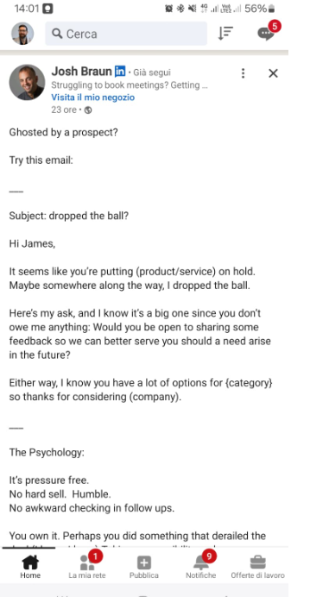

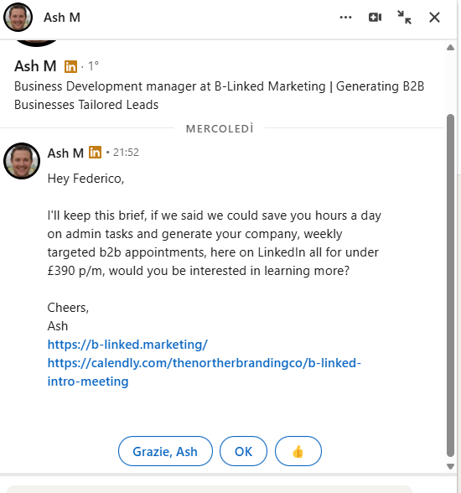

Read about the recent round - congrats''. Sure you're focused on growth right now. Lots of {insert industry} companies that raise struggle due to {insert problem}. Here's a short step by step of how to get started the right way. Hope it's helpful. Cheers, Chris''

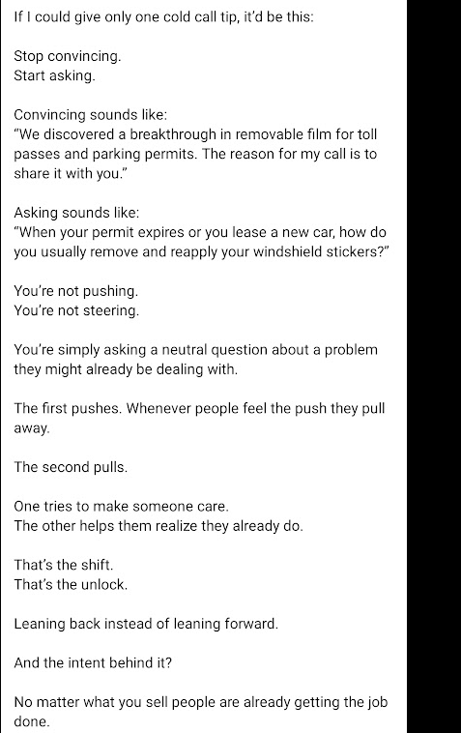

Questo è buon esempio di email a freddo.   
  
Sì, puoi pure copiare il template,   
ma è la psicologia dietro che ci sta dietro che ti aiuterà davvero a farlo funzionare con il tuo pubblico.  
  
----  
  
Ciao Luca, la maggior parte dei ciclisti amatori si affida ancora agli specchietti o a “girarsi spesso indietro”.  
  
Questo, nella pratica, si traduce in situazioni tipo:   
  
“Non mi ero accorto della macchina dietro.”  
  
“Mi ha superato a un soffio.”  
  
Oppure:  
  
“Evito certe strade perché mi sento insicuro.”  
  
Succede molto più spesso di quanto si pensi.  
  
I ciclisti che usano il Garmin Varia raccontano tutta un’altra storia:  
  
hanno avvisi precisi in tempo reale su veicoli in avvicinamento e pedalano più tranquilli, più sicuri, più concentrati.  
  
Nessun abbonamento da sottoscrivere.  
Nessuna distrazione.  
  
Solo un radar intelligente che ti fa vedere (e sentire) cosa succede alle tue spalle, molto prima che tu possa accorgertene.  
  
Lo so: spendere più di 150€ per un accessorio può sembrare troppo.  
  
Soprattutto se hai già investito tanto nella bici.  
  
Ma ti chiedo:  
  
Ci sono condizioni in cui prenderesti in considerazione un dispositivo che può letteralmente salvarti la vita?  
  
---  
  
Perché funziona?  
  
1.Apertura mirata  
  
“Luca, la maggior parte dei ciclisti amatori si affida ancora…”   
  
Crea contesto immediato e mostra familiarità con il problema. Non sembra un messaggio generico.  
  
2. Problema condiviso  
  
“Non mi ero accorto… mi ha superato troppo vicino…”  
  
Sono problemi reali, sentiti.   
Non stai cercando di convincere: stai dimostrando che comprendi e quindi, in un certo modo, ascolti.  
  
3.Soluzione specifica  
  
“Chi usa il Garmin Varia racconta tutta un’altra storia…”  
  
Niente iperboli. Solo una soluzione concreta a un problema comune.  
  
4. Abbassamento del rischio  
“Nessun abbonamento. Nessuna distrazione.”  
  
Smonta subito le obiezioni principali (costi nascosti, complessità).  
  
5. Conversazione, non vendita  
“Ci sono condizioni in cui lo prenderesti in considerazione?”  
  
Non è un pitch. È un invito al dialogo. E questo fa tutta la differenza.

5/14/25 The 60-Minute LinkedIn Pipeline Blueprint

<https://www.loom.com/share/1916eb7fa655404baf5c8cab25cc7c0d>

social selling 🡪 staying top of mind

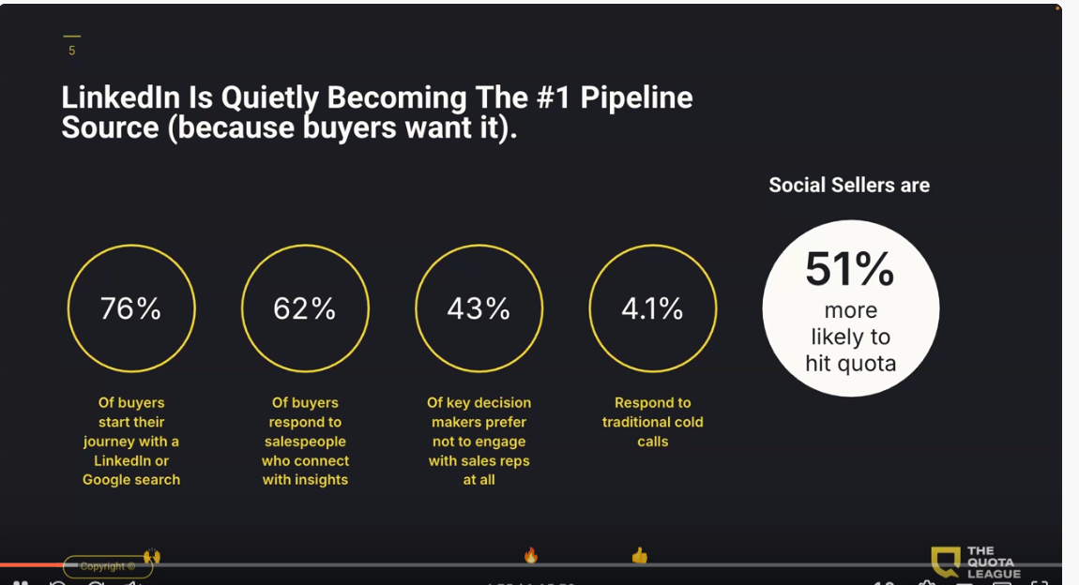

* Video DM

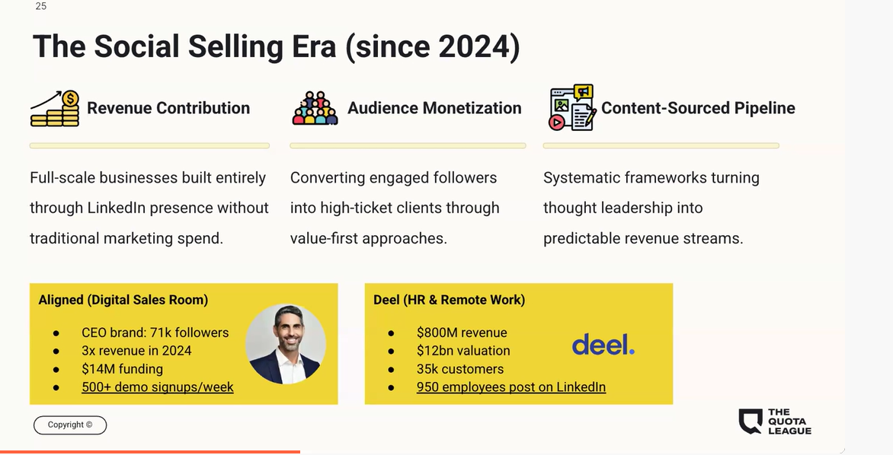

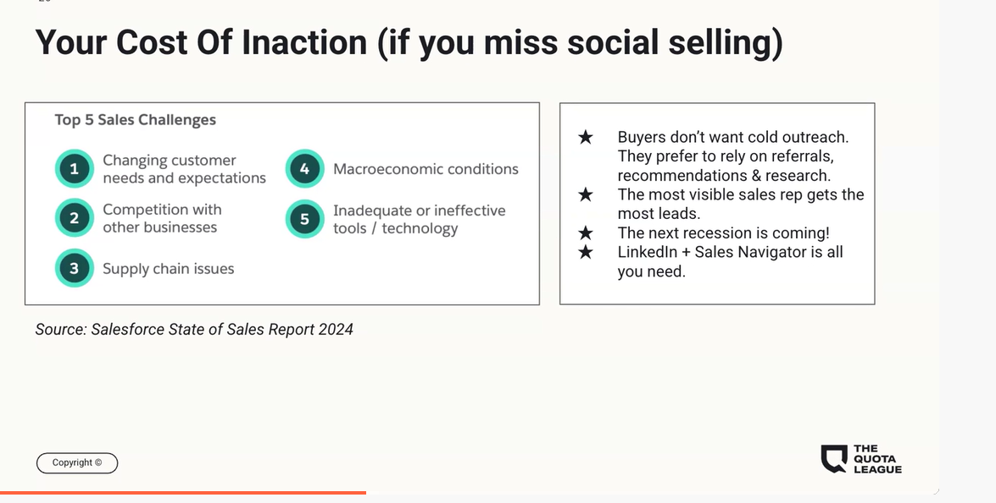

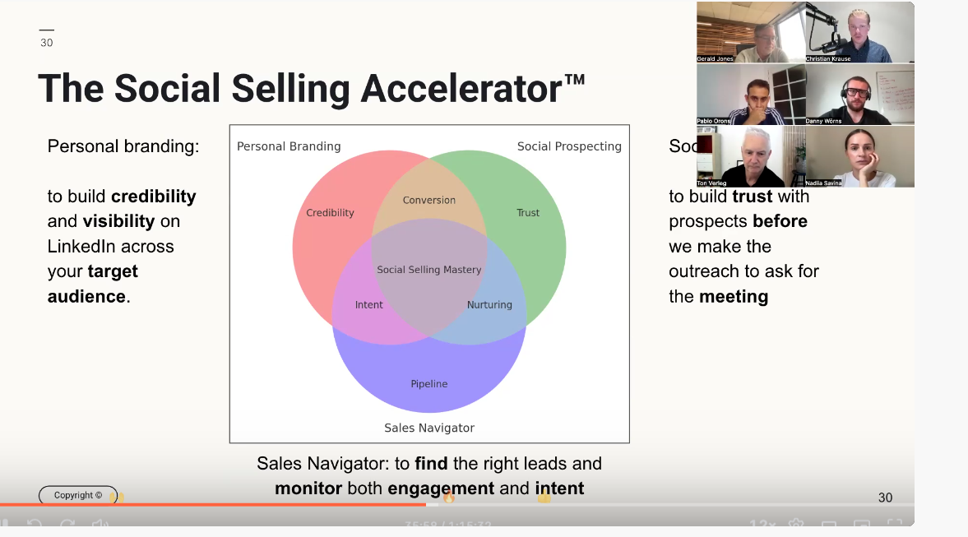

* 1. Linkedin profile optimization
  2. Personal branding
     1. Conent pillar
        1. Life post
        2. Career post: becme trusted
        3. Product post: leverage trust
        4. Trend: trust e rlelecone

Ex. Listicle:

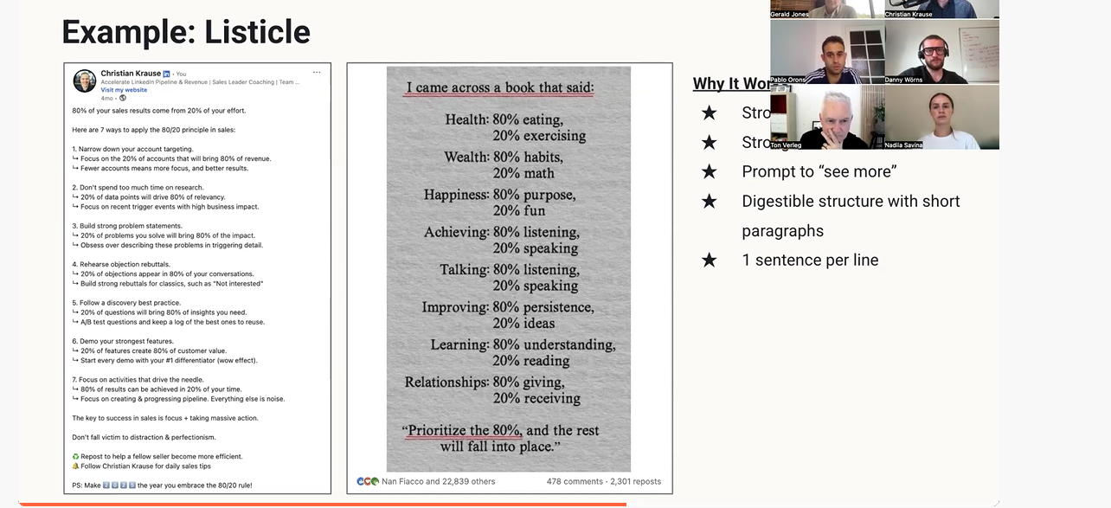organization in linkedin

0 Call list

1 Cohort (invite)

1 Meeting (nurture)

2 Replied (book meeting)

3 Message sent (follow-up)

4 Targeted (ICP)

5 Closed/lost (revive)

Alert section, nautomation, buyer personas

Social prospecting – outreach

Video DM –

Aim for the 10 touch point (10 to 18)

Open profile, groups

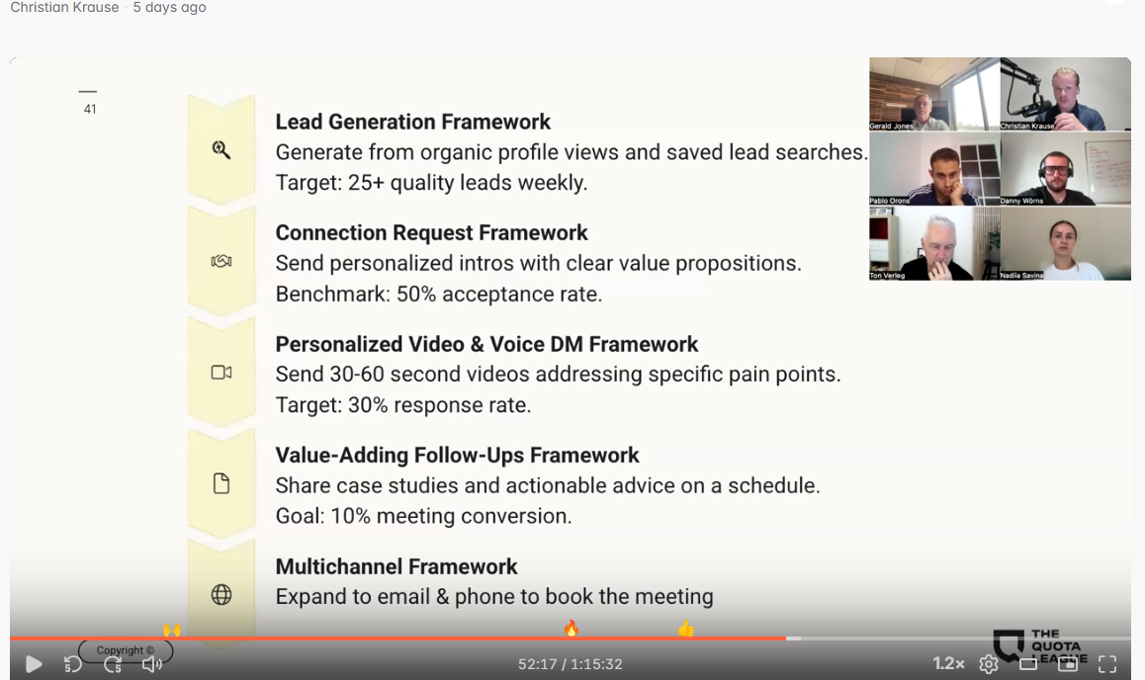

\_\_\_\_\_\_\_\_\_\_\_\_\_\_\_\_\_\_\_\_\_\_\_\_\_\_\_\_\_\_\_\_\_\_\_\_\_\_\_\_\_\_\_\_\_\_\_\_\_\_\_\_\_\_\_\_\_\_\_\_\_\_\_\_\_\_\_\_\_

**The 1-Sentence Email**

Subject: [Process / Topic]

Hi Marcus,

If we could help your team cut sales cycles in half and close 27% more deals, without hiring or changing your tech stack, would that be worth a quick chat?

Best,

Alan

P.S. Saw your team hit a new revenue milestone, congrats. Always great to see momentum like that!

**Pain Point + Case Study Strategy**

Hey {{firstName}}, are you experiencing {{pain point}} / how are you managing {{pain point}}?

The reason I’m asking is because we help {{job title}} at {{subniche}} solve {{pain point}} by {{offer}}.

Just recently, {{case study}} achieved {{transformation}} in {{timeframe}} after working with us and made a quick video outlining how we’d do something similar for {{companyName}}.

Is this something of interest?

**The Trigger + Pain + Proof + CTA approach**

Hey [name]

Saw you [relevant trigger], Imagine you’re/thought you’d [implication based on trigger]

Usually, our customers struggle [main problem related to ICP]

So [dig into the pain]

We’ve been helping [social proof]

[positive outcome & how your solution did that]

[Soft CTA]

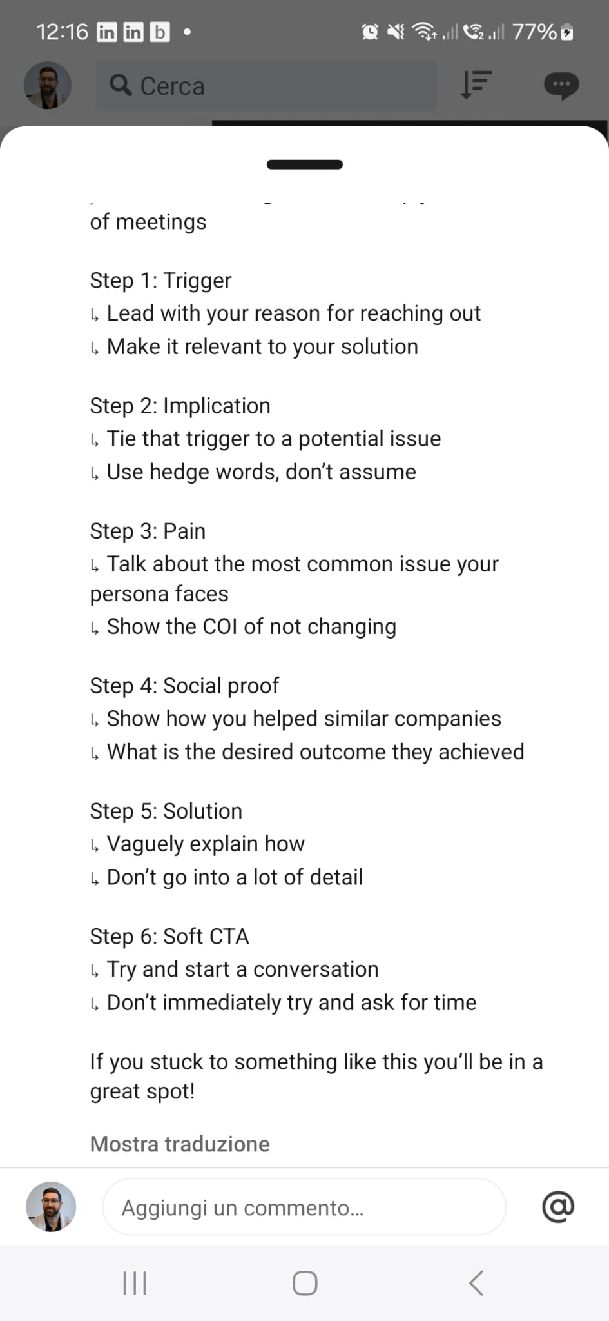

**[](https://www.linkedin.com/in/quotaleague?miniProfileUrn=urn%3Ali%3Afsd_profile%3AACoAABVHzusBxs_lZXvA8Khdlcgs9P5J_kEPYVg" \t "_self)**

[**Christian KrauseChristian Krause** • Già seguiInfluencer • Già seguiMake LinkedIn Your Pipeline Engine | Social Selling Training for sales teams | Sales Leader Coaching | Monthly Live Cohort | Free PlaybookMake LinkedIn Your Pipeline Engine | Social Selling Training for sales teams | Sales Leader Coaching | Monthly Live Cohort | Free Playbook](https://www.linkedin.com/in/quotaleague?miniProfileUrn=urn%3Ali%3Afsd_profile%3AACoAABVHzusBxs_lZXvA8Khdlcgs9P5J_kEPYVg)

**[Visita il mio sito web](http://www.quotaleague.com/playbook" \t "_blank)**

1s • Modificato • 1 settimana fa • Modificato • Visibile a tutti su LinkedIn e altrove

I made more money in May than in my entire 1st year as an SDR. 5 key sales skills that got me there:  
  
1. (𝗗𝗶𝘀)𝗾𝘂𝗮𝗹𝗶𝗳𝗶𝗰𝗮𝘁𝗶𝗼𝗻   
↳ You have to know your ideal customer profile (ICP)  
↳ Softly qualify budget, need, authority, timeline  
↳ Have the courage to walk away from bad fits  
  
2. 𝗣𝗿𝗼𝘀𝗽𝗲𝗰𝘁𝗶𝗻𝗴   
↳ Lead with business problems, not features   
↳ Cut through the AI noise with relevance  
↳ Master video prospecting (game changer)  
  
3. 𝗗𝗶𝘀𝗰𝗼𝘃𝗲𝗿𝘆   
↳ Uncover the Cost Of Inaction to drive urgency  
↳ Map out the entire decision making committee   
↳ Ask the hard questions that competitors avoid  
  
4. 𝗖𝗹𝗼𝘀𝗶𝗻𝗴   
↳ Create mutual action plans with clear next steps   
↳ Get multiple stakeholders involved from the start   
↳ Hold prospects accountable to their commitments  
  
5. 𝗦𝗼𝗰𝗶𝗮𝗹 𝗦𝗲𝗹𝗹𝗶𝗻𝗴   
↳ Build your personal brand on LinkedIn   
↳ Use likes, comments or profile views for outreach  
↳ Nurture your target audience with value over time  
  
The biggest game changer so far?  
  
The ability to generate my own leads from LinkedIn.  
  
This will be a top hiring criteria for future sellers.  
  
No pipeline? Go on LinkedIn.  
No brand awareness? Build it on LinkedIn.  
No meetings in the calendar? Book them on LinkedIn.  
  
Building your brand is future-proofing your sales career.  
  
Agree or disagree?👇   
  
♻️ Repost and share this in your team Slack  
🔔 Follow [**Christian Krause**](https://www.linkedin.com/in/quotaleague/) for daily LinkedIn sales tips  
  
📌PS: Want to crush your 2025 quota and book 20-30 meetings per month on LinkedIn? Join our Social Selling cohort in June: [**https://lnkd.in/ev5iWM6s**](https://lnkd.in/ev5iWM6s)

Mostra traduzione

[**Josh Braun**](https://www.linkedin.com/in/josh-braun?trk=public_post_feed-actor-name)Josh Braun is an Influencer

Struggling to book meetings? Getting ghosted? Want to sell without pushing, convincing, or begging? Read this profile.

6d

My favorite cold email word? Without. Why? Because it doesn’t just promise gain. It promises relief. “Train your dog to focus without yelling, punishing, or spending hundreds on obedience school.” That word speaks to pain avoidance. It gently reminds people of everything they hate about the current way without saying they’re doing it wrong. It flips the script: Instead of “Here’s what we do,” it says, “Here’s what you won’t have to deal with anymore.” People don’t want more. They want less.

[**Aaron Reeves**](https://uk.linkedin.com/in/aaron-reeves-sales?trk=public_post_feed-actor-name)

I help tech sales SDRs & AEs book 10+ meetings every month through cold outbound using a proven system | Founder Outbound OS

6d

How to make the perfect cold email (in 7 steps + scripts) Cold email can be tough. But it’s also one if the best ways to build pipeline. I used this framework to book 100s of meetings. So let’s get into it! Step 1: Trigger ↳ Show why you are reaching out ↳ Lead with why them why now Step 2: Implication ↳ Make a hypothesis on this trigger ↳ Show why they should care Step 3: Pain ↳ What do they do in their day to day ↳ What potential issues can they have with it Step 4: COI ↳ Show what happens if they don’t change ↳ Loss aversion is powerful to prospects Step 5: Social Proof ↳ This builds a ton of trust ↳ Use relevant results of people you’ve helped Step 6: Solution ↳ What did you do to help others ↳ Keep it brief and build interest Step 7: Soft CTA ↳ Start a conversation ↳ Don’t force a meeting straight away BONUS: Data ↳ You need valid emails to get replies ↳ Use Seamless to get the right info Checkout Seamless' data here: [**https://lnkd.in/e3bdNm5u**](https://www.linkedin.com/redir/redirect?url=https%3A%2F%2Flnkd%2Ein%2Fe3bdNm5u&urlhash=fUzw&trk=public_post-text) What else would you add to make a killer cold email? (I also added a bonus follow up email in the comments 👇) Enjoy this? ♻️ Repost it to your network and follow [**Aaron Reeves**](https://uk.linkedin.com/in/aaron-reeves-sales?trk=public_post-text) & [**Outbound OS**](https://www.linkedin.com/company/the-outbound-os?trk=public_post-text) for more P.S want to finish Q2 strong and set yourself up for a record Q3 150%+? I’m launchign the summer sprint program this month, if you want the details DM me “SPRINT”

The top 4 sales nav filters (and how to message each) If you want replies, you HAVE to lead with relevancy So here are 4 filters I’d use today and how to message each one for context + conversion: 1.⁠ ⁠Following your company If a prospect is following your company, it’s unlikely they’ll be doing it for no reason. Maybe they have used your product before, maybe they are just a fan, either way it’s great. Talking to people who’ve already heard of you is 10x easier than a complete stranger. What to say: “Hey {name} saw you’re following {your company} on LinkedIn, curious do you just like our content or are you looking into {what your company does}? This is super simple and looks to start the conversation; no matter what they say to this it gives you an in. 2.⁠ ⁠Viewed your profile recently ALWAYS start with the people who know who you are. This is why posting content is such a hack, as it can lead to thousands of relevant viewers every week. What to say: “Hey {name}, noticed you checked out my profile. Curious, are you just enjoying the content or looking to {achieve outcome you provide}? We don’t assume why they are viewing instead, we look to just initiate a chat, from here we can take it to a meeting if it makes sense later 3.⁠ ⁠Changed jobs Decision makers are brought in to have an impact. They will want to show they are positively impacting the company and most budget is actually spent in the first 3 months, so get in there early. What to say: “Hey {name}, noticed you recently joined {company} as {title}. Thought you could be looking into how you’re managing {issue} Most people typically {pain} How are you managing that today? With this, we lead with the trigger, tie to what could be an issue, show we know their world by explaining the issue, then ask an open-ended question to start the chat. 4.⁠ ⁠Posted on LinkedIn If people are active on the platform the chance they will respond is SO much higher. So use their posts as a reason to start a chat, lead with the topic and go from there What to say: “Hey {name} loved your post about {topic} last week. {share your thoughts on it} How are you going about managing {issue} at the minute? Key thing here is to be genuine, actually read their post, and send a thoughtful message, not a pitch slap. LinkedIn can be one of the best platforms when you use it well, hopefully, this helps as a base for you! I also attached a bonus message example in the comments, Go check it out! 👇 P.S. If you want my free LinkedIn templates, get them in the comments below 🙂

Content is a cheatcode when you get it right, here is my exact breakdown Generating demand on LinkedIn comes to 3 parts of the funnel TOFU, MOFU, BOFU TOFU - Top of funnel to get traffic & eyeballs; this can be funny skits (you & [\*Tom Boston\*]([**https://www.linkedin.com/in/nia-woodhouse-02257a168/recent-activity/all**](https://www.linkedin.com/in/nia-woodhouse-02257a168/recent-activity/all?trk=public_post_comment-text)/#) crush this) or giving away resources etc MOFU - Educational content to show why you are right to help your buyer; how to's, guides, video breakdowns etc BOFU - This is showing real results; case studies, client wins, behind the scenes etc The majority should be TOFU & MOFU to get the eyes & educate them so they view you as a thought leader. Then convert in those DMssss Commetning is goated too You can leverage soemone else's audience and if you deliver value get traction directly to your page. Don't just say "Nice post" instead say something like the comment I just did 😉

1.⁠ ⁠Trigger Lead with the reason you are reaching out, what has happened in their world to make now a good time for you to message them. Make it personal and relevant to what you solve for. 2.⁠ ⁠Compliment Then give an authentic compliment on this, something that shows you actually took it in. The law of reciprocity works, so give them a real compliment. 3.⁠ ⁠CTA Then finish with a simple CTA to just continue the conversation, n pitch, no meetings, just a chat. From here, you can guide it to a meeting. BONUS: Use a P.S You don't have to do this, but for your top prospects, it's worth spending the extra time to show this message really is for them. If people see you've really taken the time they'll be more likely to respond.

📌 Sales Nav isn’t magic. But it can build you TONs of pipeline when you have: → A strong filter → A relevant message → A non-pitchy opener Most reps pull the right filter… Then drop the same 2016 pitch. Relevance = reply rate. Run these 4 with the right tone and your inbox starts to change.

View profile for Aaron Reeves

Aaron Reeves

I help tech sales SDRs & AEs book 10+ meetings every month through cold outbound using a proven system | Founder Outbound OS

1w

The 4 best CTAs to boost cold email replies

(Boosted reply rates from 3% to 11%)

Your CTA can make or break your email.

- Too vague and you get ignored.

- Too pushy and you get ignored.

You need the goldilocks zone, just right

So here are 4 CTAs I’ve tested that consistently outperform the rest:

1. The Lead Magnet CTA

This is giving a valuable resource wiht no ask.

You want to make it a no brainer to say yes, what could you give to help them

Make sure the resoruce is related to the context / pains in your email

Structure + Example:

We made a {resource} on {topic}, want me to send it over?

We made a doc on our top 5 emails that got 10% reply rates, want me to send it over?

Why it works:

You are making their life easier, why would they say no?!

2. The Soft Call CTA

This is a classic and it still works for a reason.

You are not begging for time, or sending a link to a demo, you’re starting the conversation.

The lower the friciton of the ask, the higher % chance they respond. Mke it effortless.

Structure + Example:

Think this could help your team?

Worth a chat?

Why it works:

It is easy for the prospect to say yes too, we just need the intial yes.

3. The Value-Driven CTA

This is similar to the soft call to action, but we're tying it to getting them a desired result.

The key to this working is really understanding your ICP and knowing the KPIs they care about.

If you can offer a chance for them to make it easier to hit their numbers, they'll say yes.

Structure + Example:

If we could help you {achieve outcome}, would that be worth a chat?

If we could help your team get 10%+ reply rates, would that be worth a chat?

Why it works:

Again you are tying the chat to only if you can help them hit their goal, this is a simple yes.

4. The Video CTA

This is one of my favorites, as it's often one of the least used.

Most reps aren't willing to go the extra mile.

Make it easy for them, offer to give them a video to explain the context of your email further.

Structure + Example:

Mind if I share a quick video?

Mind if I send you a 2m Loom?

Why it works:

Again, you're offering to give them something with no ask. Reciprocity always works in sales.

If you’re struggling to get replies…

Try testing these CTAs in your next 10 emails.

Track reply rates. Tweak wording. See what lands best with your audience.

P.S If you want me 5 best email frameworks for free, get them in the comments! 👇

📌 The best cold email CTA? - Low ask - High context - Clear outcome Don’t pitch. Don’t beg. Just make it easy to say yes.

📌 Your CTA is what gets the reply. Your system is what gets the meeting. If you want help crafting messaging that consistently books 10+ cold outbound meetings/month not just replies, I’m helping 4 reps in my Summer Sprint program. DM me “SPRINT” and I’ll send the details.

View profile for Josh Braun

Josh Braun Josh Braun is an Influencer

Struggling to book meetings? Getting ghosted? Want to sell without pushing, convincing, or begging? Read this profile.

2d

Cold call tip:

Don’t lead with a pitch.

Lead with a poke.

Instead of saying:

“We help teams respond to inbound leads faster…”

Say:

“How are you handling inbound leads after hours when no one’s around?”

That’s the kind of question that stings a little.

Makes them pause.

Creates tension and makes them think:

“Huh… good question.”

Tension gets attention.

Pitching is about pushing your solution.

Poking is about exposing a problem they didn’t know they had or were avoiding.

Why does this matter?

Your solution has no value without a problem.

Knowing how to ask a question that hits a nerve is a good skill to learn and master.

Buyers have the answers.

Sellers have the questions.

View profile for Haris Halkic

Haris Halkic

👇 21 free sales resources built to make your job easier

1w

10 Outreach Habits That Get Replies

It’s not magic. It’s behavior.

Here’s what top reps do differently.

1. They always start from a signal

→ A post, a job change, a trigger. No random cold touches.

2. They lead with relevance

→ Every message starts with context the buyer actually cares about.

3. They change the angle

→ Different ask, different value, different tone - each touch earns attention.

4. They keep messages tight

→ 3–4 lines. Simple structure. Clear point. Easy to read.

5. They mix channels

→ LinkedIn, email, call. It’s the full sequence that creates momentum.

6. They follow up fast

→ 2–3 days max. Long gaps = lost deals.

7. They adjust based on role

→ Exec? Talk outcomes. IC? Talk workflow. Tailor by level, not persona decks.

8. They use tools without sounding like tools

→ Automation runs the process — the message still sounds human.

9. They measure what matters

→ Copy, timing, CTA. If it moves the number, they track it.

10. They pivot the angle, not the volume

→ More touches aren’t better. Smarter ones are.

This is exactly what tools like lemlist help enable:

→ Multichannel sequencing

→ Signal-based targeting

→ CTA testing and smart pauses

→ Real motion, not just message dumps

If you're building serious outreach systems, it's worth a look.

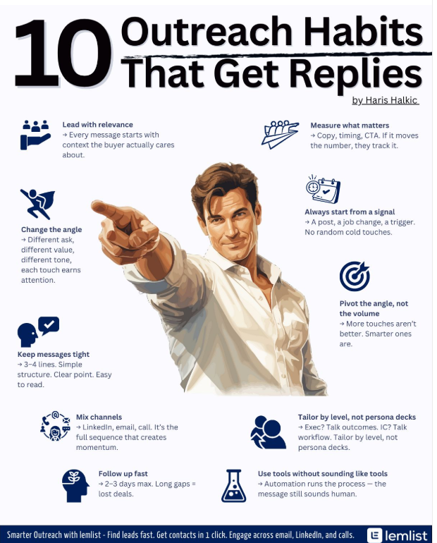

I made more money in May than in my entire 1st year as an SDR. 5 key sales skills that got me there:

1. (𝗗𝗶𝘀)𝗾𝘂𝗮𝗹𝗶𝗳𝗶𝗰𝗮𝘁𝗶𝗼𝗻

↳ You have to know your ideal customer profile (ICP)

↳ Softly qualify budget, need, authority, timeline

↳ Have the courage to walk away from bad fits

2. 𝗣𝗿𝗼𝘀𝗽𝗲𝗰𝘁𝗶𝗻𝗴

↳ Lead with business problems, not features

↳ Cut through the AI noise with relevance

↳ Master video prospecting (game changer)

3. 𝗗𝗶𝘀𝗰𝗼𝘃𝗲𝗿𝘆

↳ Uncover the Cost Of Inaction to drive urgency

↳ Map out the entire decision making committee

↳ Ask the hard questions that competitors avoid

4. 𝗖𝗹𝗼𝘀𝗶𝗻𝗴

↳ Create mutual action plans with clear next steps

↳ Get multiple stakeholders involved from the start

↳ Hold prospects accountable to their commitments

5. 𝗦𝗼𝗰𝗶𝗮𝗹 𝗦𝗲𝗹𝗹𝗶𝗻𝗴

↳ Build your personal brand on LinkedIn

↳ Use likes, comments or profile views for outreach

↳ Nurture your target audience with value over time

The biggest game changer so far?

The ability to generate my own leads from LinkedIn.

This will be a top hiring criteria for future sellers.

No pipeline? Go on LinkedIn.

No brand awareness? Build it on LinkedIn.

No meetings in the calendar? Book them on LinkedIn.

Building your brand is future-proofing your sales career.

Agree or disagree?👇

♻️ Repost and share this in your team Slack

🔔 Follow Christian Krause for daily LinkedIn sales tips

📌PS: Want to crush your 2025 quota and book 20-30 meetings per month on LinkedIn? Join our Social Selling cohort in June: <https://lnkd.in/ev5iWM6s>

Hey federico tempella,

How I Write Emails That convert (without being salesy)

(But Still Book 5–10 Meetings a Week)

Most likely THIS is what you hate the most every single day:

You write someone a cold email or LinkedIn DM…

And they leave you on read.

• No reply.

• No meeting.

• Nothing.

Here’s the truth: Most sellers are still selling too early. And it shows.

Let’s play a quick game of “spot the difference”

The Cold Email That Feels… Cold

Subject: 10X your leads with X solution.

“Hey Julia, I help SaaS founders book 100+ meetings/month using our proven cold email engine.

Let’s hop on a quick call this week. When works best for you?”

UUUUGhhh… nah.

Feels pushy. All about you. No waaaarm up, no reason to care. NO NOTHING.

The Cold Email That Feels Like a Favor

Subject: fix your homepage

“Hey Julia, came across your product while checking out [Brand]. Super cool! I actually shared it with a friend who runs a remote team.

While I was on your homepage, I noticed two little things that might be affecting sign-ups. Happy to send over the quick ideas if you want, no pitch."

Boom.

It’s human.

It’s helpful.

And it opens the door naturally.

So here’s the big shift:

Stop selling. Start helping.

Or how I call it: Helping is the new selling

When you lead with value → You don’t have to “sell” in the traditional way.

• You’re just being useful.

• Starting conversations.

• Building trust.

• Making people curious.

That’s what creates the real sales opportunities.

Pro Tip:

This works for email just like it does for LinkedIn DMs.

The format changes. The tone doesn’t.

It’s not magic. Just modern selling done right.

And when it’s time to invite them to a call?

• It’ll feel natural.

• They’ll want to hear more.

Because you already gave something first.

That’s how you book 5–10 meetings a week…

Without feeling like a pushy salesperson.

So, if you DESIRE sooo badly to become a Modern Seller, and not being stuck as a pushy one...

Hey federico tempella,﻿

**The objection isn’t the problem. It’s your freeze response.**

A rep told me last week: *“The second someone says 'not interested,' my brain goes blank. I just thank them and hang up.”*

That’s not selling. That’s surrendering.

The best reps don’t overpower objections.

They **reroute** them, with calm, control, and curiosity.

And credit where it’s due, this reframe was sparked by my good old friend **Giulio Segantini**, who reminded me that objections aren’t walls… they’re doorways. You just need the right way to knock.

Enter:

**The L.A.S. Loop**

**L = Level With Them**

Break the pattern with honesty

**A = Anchor to Reality**

Bring it back to a shared business truth.

**S = Shift the Focus**

Make it about them, not your product.

|  |
| --- |
|  |

Objections don’t kill momentum. Poor reactions do

Handle it with confidence, not defensiveness.

Make it about them, not your product.

\_\_\_\_\_\_\_\_

Hey federico tempella,

The 33-word cold email that helped a startup founder land 6 meetings in a week

A founder I work with was stuck. She had no idea how to book meetings over emails

• She was friendly

• She was polite

• She was nice

That's why no one was answering. So we tested something different.

We stripped her email down to one question, one win, and one ask.

That same week? 6 CEOs replied.

Here’s the exact template for you to use:

Hey {{first\_name}} – Curious if you’re open to innovation: [TOPIC]? [CASE STUDY + IMPACT + KPI – USUAL PROBLEM] If it makes sense Q3/Q4, should we set up a call?

Example for a SaaS CEO:

Hey Monica – Curious if you’re open to innovation re: outbound conversion? Helped a $20M ARR SaaS cut CAC by 28% by auto-scoring cold leads before reps touched them. If it makes sense Q3/Q4, should we set up a call?

No fluff. No “hope you’re doing well.” Just a sharp hook and a clear reason to talk.

It worked for her, and it works if you’ve got a real outcome behind your message.

Adapt it, use it, send it. AND WIN.

+150 extra frameworks and examples inside The Modern Seller Program

Start winning now, stop investing in BS things and invest in yourself

Alan "Modern Seller" Ruchtein.

# Three proven outreach methods (with templates)

These strategies work because they don’t feel like sales tactics…

They feel like genuine conversations.

And that’s why they convert better.

If your outreach isn’t working, it’s probably because it sounds like outreach.

Try this instead - and watch what happens.

# Strategy 1: The Compliment + Question Approach

People hate being pitched, but they love talking about their business. That’s why this works.-

\*\*Step 1:\*\* Start with a specific compliment.

\*\*Step 2:\*\* Ask a close-ended question to uncover a pain.

For example:

<aside>

➡️

"Hey [name], I really liked your recent post on [topic]. Totally agree. How’s LinkedIn lead-gen working for you - plenty of sales calls?"

</aside>

If they say "It could be better" → Offer a call.

If they say "It’s going well" → Ask what their next goal is.

Keep digging until you uncover a pain point or desire, then offer a call. This keeps the conversation natural instead of forcing a pitch.

---

# Strategy 2: The Free Resource DM

Not everyone is ready for a sales call immediately. But they’re happy to say yes to something that helps them for free.

\*\*Step 1:\*\* Create a free lead magnet that solves a specific problem.

\*\*Step 2:\*\* DM prospects and ask if they’d like access.

For example:

<aside>

➡️

"Hey [name], I put together a quick guide on [specific pain point]. Want me to send it over?"

</aside>

If they say yes, send it, then ask a follow-up question:

"Here it is. Curious - what’s been the biggest challenge for you with [problem]?"

If a pain is revealed, offer a call. This makes outreach feel helpful, not pushy.

---

# Strategy 3: The Lead Magnet Post

This is the most scalable strategy.

\*\*Step 1:\*\* Build a free resource around one of your ICP’s biggest problems.

\*\*Step 2:\*\* Make a LinkedIn post advertising it.

\*\*Step 3:\*\* Ask people to comment a word if they want access.

For example:

<aside>

➡️

"I just put together a free playbook on how I book 10+ sales calls per day. If you want a copy, comment ‘CALLS’ below and I’ll send it over."

</aside>

\*\*Step 4:\*\* Then, DM everyone who comments.

"Hey [name], saw you wanted the playbook - here’s the link! Also, how’s LinkedIn lead-gen working for you - plenty of sales calls?"

Once they respond, start a conversation and move to a call.

Hey Federico Tempella,

When I tell sellers about these frameworks, I often hear:

"Sounds great, Aaron... but I barely have time to hit my numbers as is.

​

How am I supposed to implement new systems?"

I get it...

I felt the exact same way as an SDR at Fruugo.

I was:

Sending 100s of generic emails

Making endless cold calls

Working longer hours

Still missing quota

Then I realized something that changed everything:

Working harder wasn't the answer.

Working systematically was.

The moment I stopped trying to "hustle harder" and started implementing proven systems, everything changed:

Less time writing emails

Higher response rates

More qualified meetings

Consistent quota achievement

Here's the reality:

You're already spending time on outreach.

The only question is:

Are you spending it on proven systems or reinventing the wheel?

Want to see how to implement these frameworks without disrupting your current workflow?

I'm doing strategy calls where I'll:

Review your current process

Show you quick-implementation steps

Help you build a sustainable system

​Grab some time with me here!​

Let's book more meetings together,

Aaron

P.S.

In my next email, I'll share some serious results from sellers taking advantage of my coaching and frameworks.

Stay tuned.